Cole Driggs’ Editing Portfolio

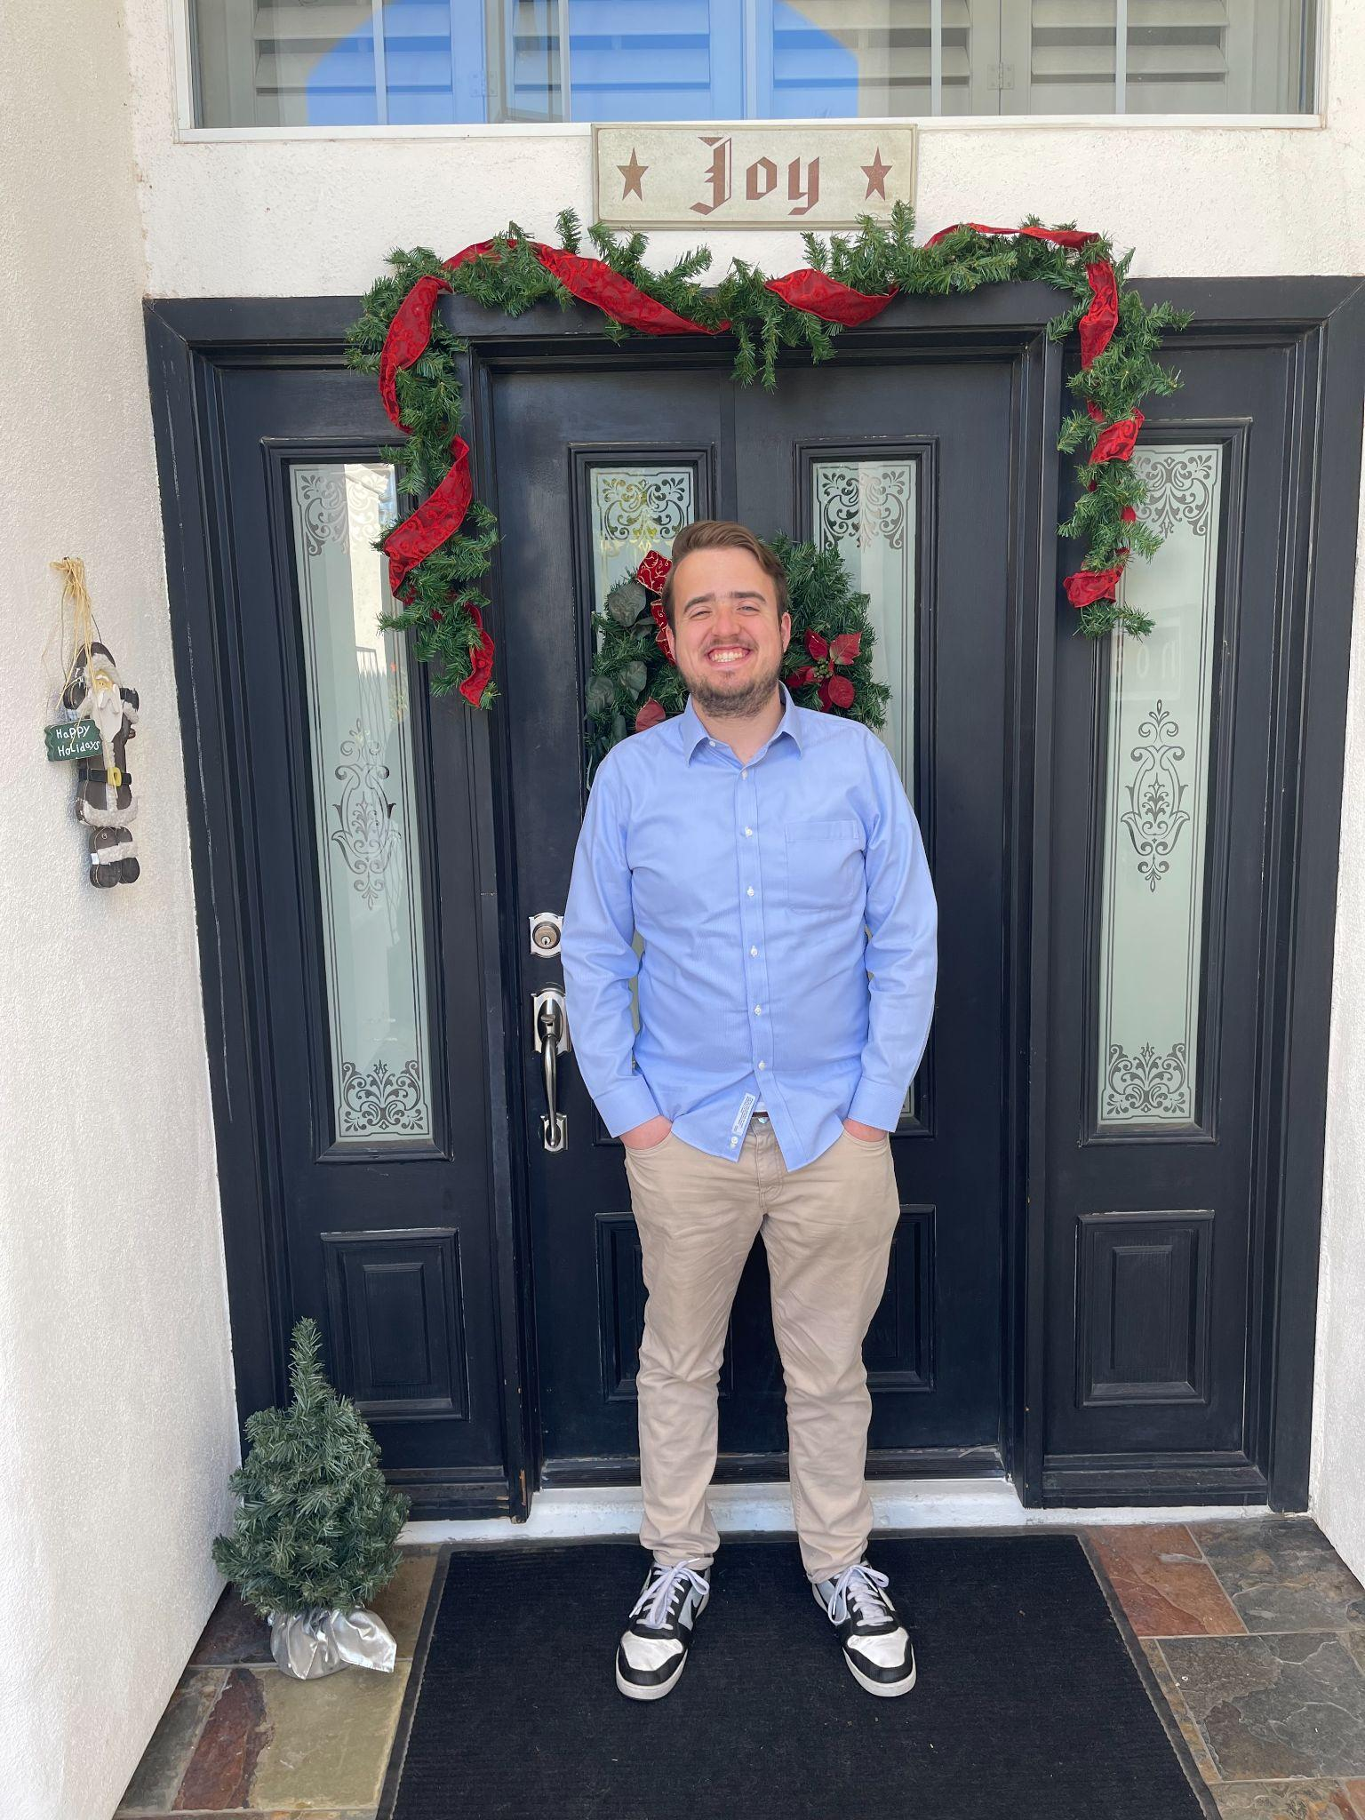

PREPARED FOR
UVU’s Editing Class (Spring 2023 Semester)
Professor Carter

PREPARED BY
Cole Driggs
(480) 440-5524
coledriggs@gmail.com

APRIL 26TH, 2023

PROFESSOR CARTER

UTAH VALLEY UNIVERSITY
800 W UNIVERSITY
OREM, UT 84058

Dear Professor Carter,
Please find my final class portfolio for your kind consideration. I have listed my thoughts on the questions assigned in headings for greater coherence.
Structure: This portfolio lists these components in the respective order: the editing log, table of contents, and copies/queries of my editing. Instead of including the entire work itself, I have included passages from the work with my thoughts attached.
Summary of Editing Experience: These assignments have resulted from my membership in the Touchstones literary journal staff and our in-class assignments. Since I came with little editing experience, much of the time spent with these assignments was cases of “trial and error”- which resulted in having to add a few more hours for each project. On another note, nobody in our team knew how to use OneNote, so additional hours (logged on 3/10 and 3/31) were dedicated to getting past those learning curves.
Editing Style: I understand how debilitating it can feel as a reader to have your work completely torn apart, so I wanted to approach each piece with what can be seen as a “light” and “writer-centered” approach. For example, in one poem I edited entitled “Ectopic”, the editor insisted on keeping the word “anesthetized” in the piece when the head editors wanted the word rephrased altogether. Instead of choosing one side or the other, I spoke with the author Issac and rephrased the section of the poem to a phrase that was correct enough for the editors to accept. In this case, I chose to focus on style rather than overall correctness.
Implementing Chicago and Subversive Copy Editor Study Materials: Our use of the Chicago Manual of Style and the Subversive Copy Editor helped me realize how I can edit in a way that can be a more positive experience for the writer. Quite honestly, as I was editing papers before this class, I would purposely leave out commenting on certain principles the writer needed to fix out of the fear I was commenting too much. Through these readings, I learned how to effectively query the author instead of micromanaging them, which helped my editing feel more digestible to the author. I also learned how to effectively manage my time as an editor which has helped me to be more productive and proficient at the editing I do.
Final Comments: Overall, I feel slightly more confident in my editing skills compared to the start of the semester. I have personally noticed throughout my education that it usually takes me a little while longer to learn technical concepts. However, once I get enough practice with the topic, I become good at it. I feel the same will come with my editing skills. I am taking the Advanced Editing class at UVU next semester, and I am very confident that this class will help me feel in the gaps in how to edit well. This class has been an amazing resource to help me get started with my editing expertise, and I am excited to see where the rest of my education will take me!
Feel free to ask any questions regarding my work with this portfolio. Thank you so much for all your help and support this semester!

Yours Truly,
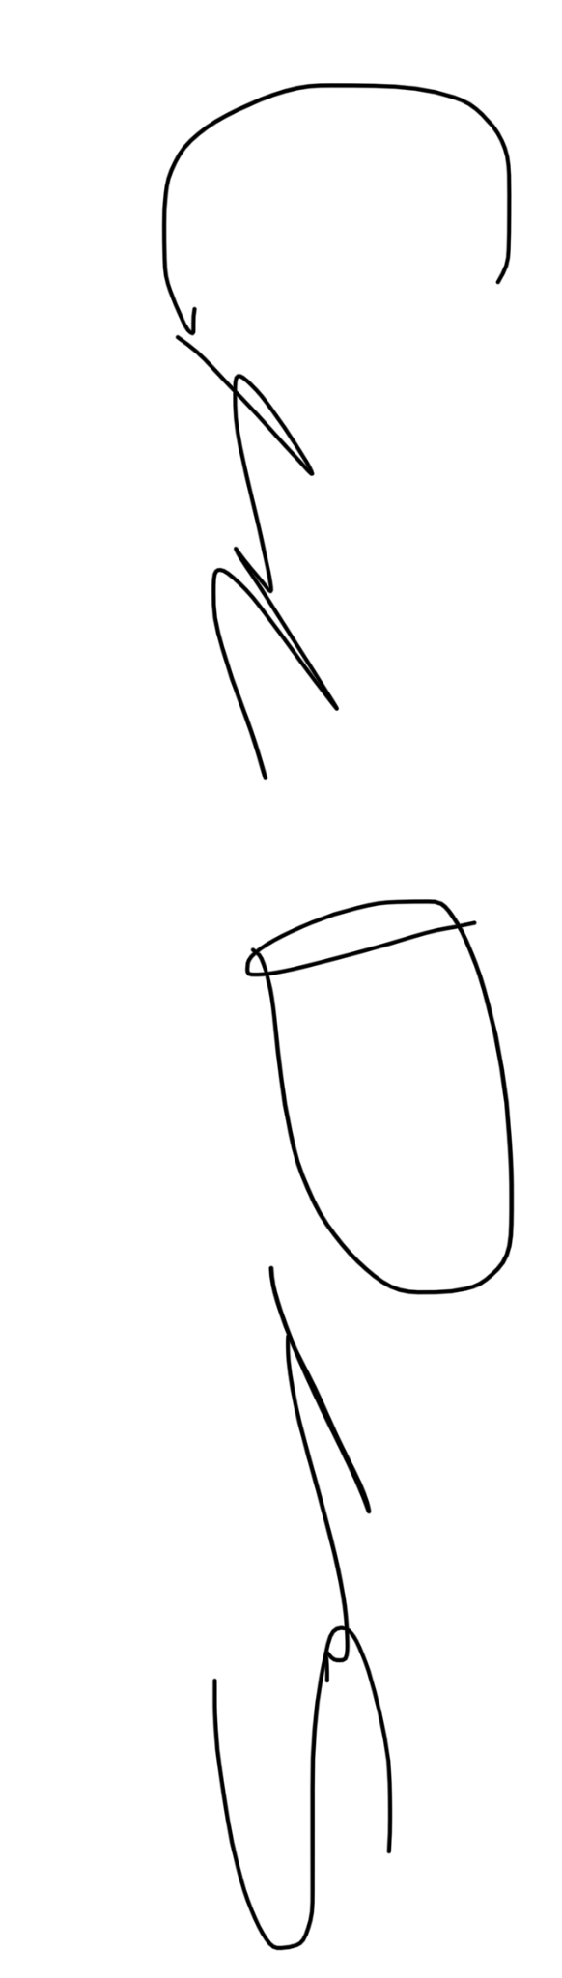
Cole Driggs
865 N 160 W Apartment 14
Provo, Utah 84604

Editing Hours Log
Midterm Portfolio Hours
Date Description of editing activity Editing Project Team Effort? Time
2/8/23 | Opening In-Class Workshop (Using Word Online, Track Changes, Choosing Articles) | JSL | Yes | 1 hr.
2/16/23 | Ectopic and Online, On Life* Manuscript Editing | Touchstones | No | 1.5 hrs
2/22/23 | In-Class Workshop (Macros Editing) | JSL | Yes | 1 hr.
2/27/23 | In-Class Workshop (Macros Editing Part 2) | JSL | Yes | 1 hr
3/7/23 | Micros Editing for Touchstones Pieces (Ectopic and Online, On Life*) | Touchstones | No | 1 hr.
3/10/23 | Handling technical difficulties with the JSL piece we were assigned to edit. | JSL | Yes | .5
 | MIDTERM TOTAL HOURS | JSL and Touchstones | = | 7.5 hrs.
Final Portfolio Hours
Date Description of editing activity Editing Project Team Effort? Time
3/29/23 | In-Class Workshop | JSL | Yes | 1 hr
3/30/23 | Last minute edits to (Dis)Connection | Touchstones | No | 1.5 hrs
3/31/23 | In-Class Workshop | JSL | Yes | 1 hr
3/31/23 | Creating the team memo for the JSL article | JSL | Yes | 1 hr
4/10/23 | In-Class Workshop | JSL | Yes | 1 hr
 | FINAL TOTAL HOURS | JSL AND TOUCHSTONES | = | 5.5 hrs
 | TOTAL CLASS HOURS | JSL AND TOUCHSTONES | = | 13 hrs.
 | * The editing team at Touchstones asked for us to change the name of the piece to connect it more to the rest of the pieces in the issue. (Dis)Connection and Online, On Life, are the same piece, just in different stages of the editing process.

EDITING CONTENTS

1. Journal Of Student Leadership Query
I wrote the entire query my team sent to the author during our in-class workshops.
2. Journal Of Student Leadership Micros-Editing
I attached a picture of my use of the “track changes” feature to make edits on two pages in the Journal of Student Leadership
3. Touchstones Literary Journal-Prose Piece
The finalized piece ended up winning third place in the competition section of Touchstones. I used this portion to highlight the macros comments I made on the author April’s piece, and how I make the distinction between style and correctness in my editing.
4. Touchstones Literary Journal-Poetry Piece
This section shows I approached editing poetry and copyediting.

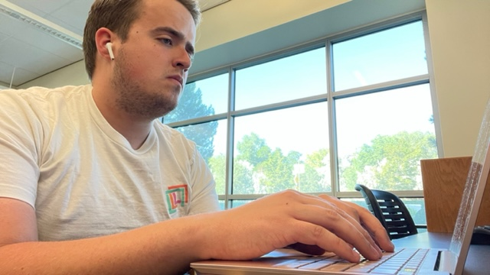

1. Journal Of Student Leadership Query

Journal of Student Leadership

Memo
To: Braxtyn Birrell
From: Team Teal (Sienna Galvez, Rihanna Turville, Anthony Nelson, Emily Reeder, Cole Driggs)
Cc: Author of Submission 2
Date: April 5th, 2023
Subject: Macro Edits- Submission 2- “How Explicit Objectives Can Influence Peer Consultant Development
Dear Braxtyn,
We are thankful for the opportunity to practice our micro-editing skills as we edit Submission 2 for The Journal Of Student Leadership. We can easily tell that our assigned author is very passionate about the article’s subject matter and claims. In particular, we love the emphasis on finding proactive ways to reform the education system with another system that has proven to work. We are satisfied with the previous group’s macro-edits, and we would like to move forward in the editing process.
There are individual comments left on our submission document, but here are some ways we can make a great paper even better.
- Thesis Statement- We would like to query the author about the general thesis statement of the paper. The original thesis statement tends to focus on the education system exclusively when the paper dives into the specifics of military education. If the author can refine the thesis to include the military, it would improve the analytical qualities of the argument.
- Convoluted Sentences- As previously mentioned, we love the passion of the military that shines throughout the paper. However, there are a few sentences marked that were hard for us to understand. If you break these sentences up or eliminate phrases, you can create an even more cohesive paper.
- Audience- The article in and of itself felt very niche to military education, which increases the overall rhetorical appeal of the paper. With this in mind, there are a few points we (as a group with no military experience) struggled to understand. The author was amazing in providing plenty of clarification with his analysis. If he could bring this clarification to his discussion on military terms, it can create a more cohesive paper.
- The Disclaimer- We think using a disclaimer is a smart move to make sure you are not overstepping any bounds, especially with the military involved. However, we feel that the disclaimer is repeated unnecessarily, which interrupts the structure of the paper. The author focuses on a very academic audience, and I feel that they would understand the disclaimer the first time.
- General Grammatical Errors- Please see our suggestions on the paper itself for general grammar and citation errors.
We appreciate the spotlight placed on the achievements of the United States Military. As editors of this subject matter, we went into particular specificities because we care about the discussed matter. Please let us know if you have any questions about our comments. We would love to help with this paper as much as we can.
Thanks again,
Team Teal

2. “How Explicit Objectives Can Influence Peer Development” Micros Editing

Note: This includes two pages of writing, but it is zoomed out so I can capture it in one photo.
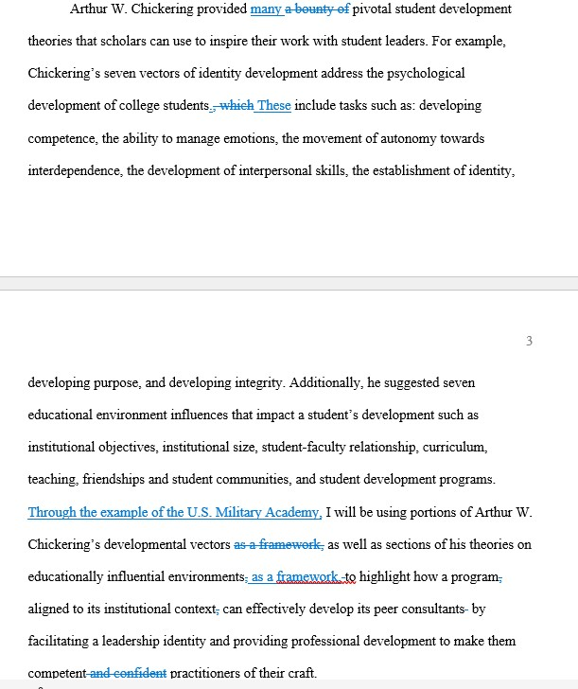

3. (Dis)connection by April Andreason (Macros Editing)

Every day there is a dead cat on her floor. It lies belly up with its paws curled in and its tail flopped over a hind leg. Based on its age, she estimates that it has died in excess of 5000 times. It dies many times a day. She reaches down and strokes the fluffy expanse of brown and cream stripes and it comes to life purring like a congested snorer with a wagging tail. You are such a dog, she reminds him fondly. He will acquiesce to be petted for an hour or more if she indulges him. She obliges him for a long stretch of time that she forgets to keep track of. Isn’t that what family is for, to bring you back to life with a gentle touch and keep you company for an hour?
She and her sisters communicate in T-shirts. I’m not procrastinating. I’m going on side quests*If you met my family, you’d understand*Crazy sisters make the best aunts*How can I miss you if you don’t go away?
Her car is on life support. Who knew making use of it only once or twice a week would kill it? The pandemic has made her a (bigger) homebody. She would take walking up the stairs to her home office over the call center any day. But her car finds itself suddenly unemployed and the despondency does it in. She is now accustomed to hooking up the IV to keep it going, clamping cables to the battery and infusing it with electricity. She is the one who severed their bond; it only wanted to be of use.
She teaches her students through a screen. Some she’s known for months, others for 5 minutes. She glimpses an array of business suits, well-worn T’s threaded with mysterious slogans she cannot read, layered dresses and pristine white cotton robes, hair free or tucked invisibly beneath scarves. Their words are flavored with different spices, different skylines, different dreams. All connect to the Great Mind, reaching out from the world to recreate their identities in a new tongue. There are some who keep their cameras off so she is left speaking with a voice echoing out of the blackness. She smiles excessively, desperate to make a connection in the dark.
She remembers the article she read about some university programs in South Korea requiring that their students date because they have become so involved in the internet and screens that they are becoming socially stunted and not dating and so contributing to the population decline. She supposes there is no danger of a screen rejecting you though it can take up all your time and money just like a relationship. But it can’t cuddle.

4. “Ectopic” by Isaac Hamilton (Editing Poetry)

The red text is the parts the author and I rephrased in person.
The blue text is the words that we added as we ran through edits in person.
Ectopic
Vomit-stained bedsheets,
The footprints of one carrying one or two upstairs,
Down the porch,
To the car,
To the hospital,
Where tears flow like blood into a toilet bowl,
An ectopic birth of cells to their premature, watery grave.

You are haunted,
Haunted by the what-ifs and what wrongs did you commit?
I know and try
to convince you
you did nothing, but
I do not know
what I feel.
For the first time in my life, tragedy strikes
and I feel numb. I have not stopped feeling
numb.

The loss of a child
is so strange when there is no body.
I hold you,
and wish I could cry,
but it is as if I am anesthetized
waiting for the surgery to be over, this twisted state to disappear,
the dream to end, the misery to hit me. But there is only
numb.

